CT102 – Assignment 1 Daniel Hannon (19484286)

1.
I. EU citizens have a “Right To Be Forgotten,” meaning that any citizen can request that search engines remove links to pages which are publicly available but where the content on a page is deemed private.

Step 1: Stop word removal – Get rid of any words which hold little to no value in terms of content of the page

EU citizens “Right To Forgotten,” that citizen that search engines links to pages which are available where content on page is deemed.

Step 2: Normailisation – make it lower case

eu citizens “right to forgotten,” that citizen that search engines links to pages which are available where content on page is deemed.

Step 3: Word stemming/ lemmitisation altering the nature of words so plurals have the same weighting as singulars and so on

eu citizen “ right to forgotten ,” that citizen that search engin link to page which are avail where content on page is deem .

II.

Tf of “page” in the above statement is 1/11 as it appears twice and there’s 22 words total.

Idf of the term “page” is log(500/300) which is roughly 0.222

Tf*idf of “page” = 1/11 * 0.511 = roughly 0.0202

2.

< 0.3, 0.25, 0.1, 0.02, 0, 0.11 >
t1 t2 t3 t4 t5 t6
< 0.35, 0, 0.3, 0.11, 0.02, 0.2 >

Document Similarity

Using the Cosine similarity formula we can deduce that

The documents have a similarity of 0.7394

3.

 | A | B | C | D
A | 0 | 1 | 0 | 1
B | 0 | 0 | 1 | 0
C | 0 | 1 | 0 | 1
D | 1 | 1 | 1 | 0

Outgoing Links

A = 2
B = 1
C = 2
D = 3

Formulas for Page Ranks
Pr(A) = 0.15 + 0.85(Pr(D)/C(D))
Pr(B) = 0.15 + 0.85(Pr(A)/C(A) + Pr(C)/C(C) + Pr(D)/C(D))
Pr(C) = 0.15 + 0.85(Pr(B)/C(B) + Pr(D)/C(D))
Pr(D) = 0.15 + 0.85(Pr(A)/C(A) + Pr(C)/C(C))

C Code to perform said calculation

#include <stdio.h>
int main() { /*Page rank Script */
double dVal = 0.85;
double a = 1.0, b = 1.0, c = 1.0, d = 1.0, a_pr, b_pr, c_pr, d_pr;
int links_a = 2, links_b = 1, links_c = 2, links_d = 3, count = 1; /*Outgoing Links and count, 0th Iteration all equal 1*/
while (1 == 1) {
a_pr = a;
b_pr = b;
c_pr = c;
d_pr = d;
a = 0.15 + (dVal * (d_pr/links_d));
b = 0.15 + (dVal * (a_pr/links_a + c_pr/links_c + d_pr/links_d));
c = 0.15 + (dVal * (b_pr/links_b + d_pr/links_d));
d = 0.15 + (dVal * (a_pr/links_a + c_pr/links_c));
printf("Iteration %d:\ta = %0.5lf\tb = %0.5lf\tc = %0.5lf\td = %0.5lf\n",count,a,b,c,d);
if ((a_pr - a <= 0.0001 && a_pr - a >= -0.0001)&&(b_pr - b <= 0.0001 && b_pr - b >= -0.0001)&&(c_pr - c <= 0.0001 && c_pr - c >= -0.0001)&&(d_pr - d <= 0.0001 && d_pr - d >= -0.0001)) break;
count++;
}
}
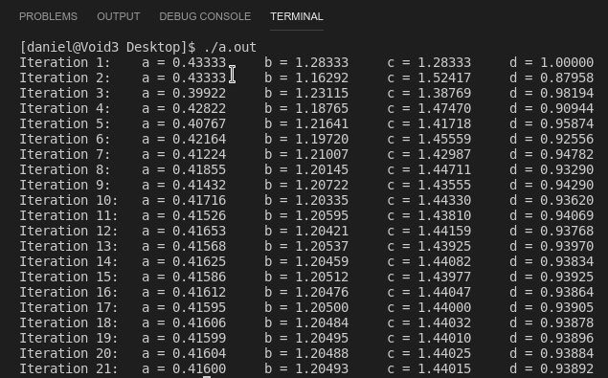
Output of program (Results converge on 21st Iteration) Final Rankings in Order C,B,D,A

“I am aware of what plagiarism is and include this here to confirm that this work is my own”

